ENSF 409 Lab 1 Inlab

Exercise 1

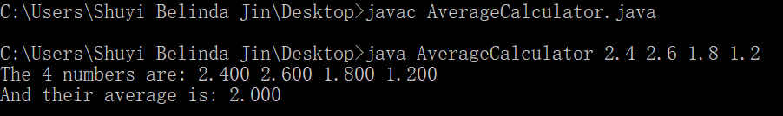

Exercise 2

